Protocol for cloning a 4kb transcript in soybean

- Reverse transcription
SuperScript IV reverse transcriptase was used. I exactly followed the protocol below. 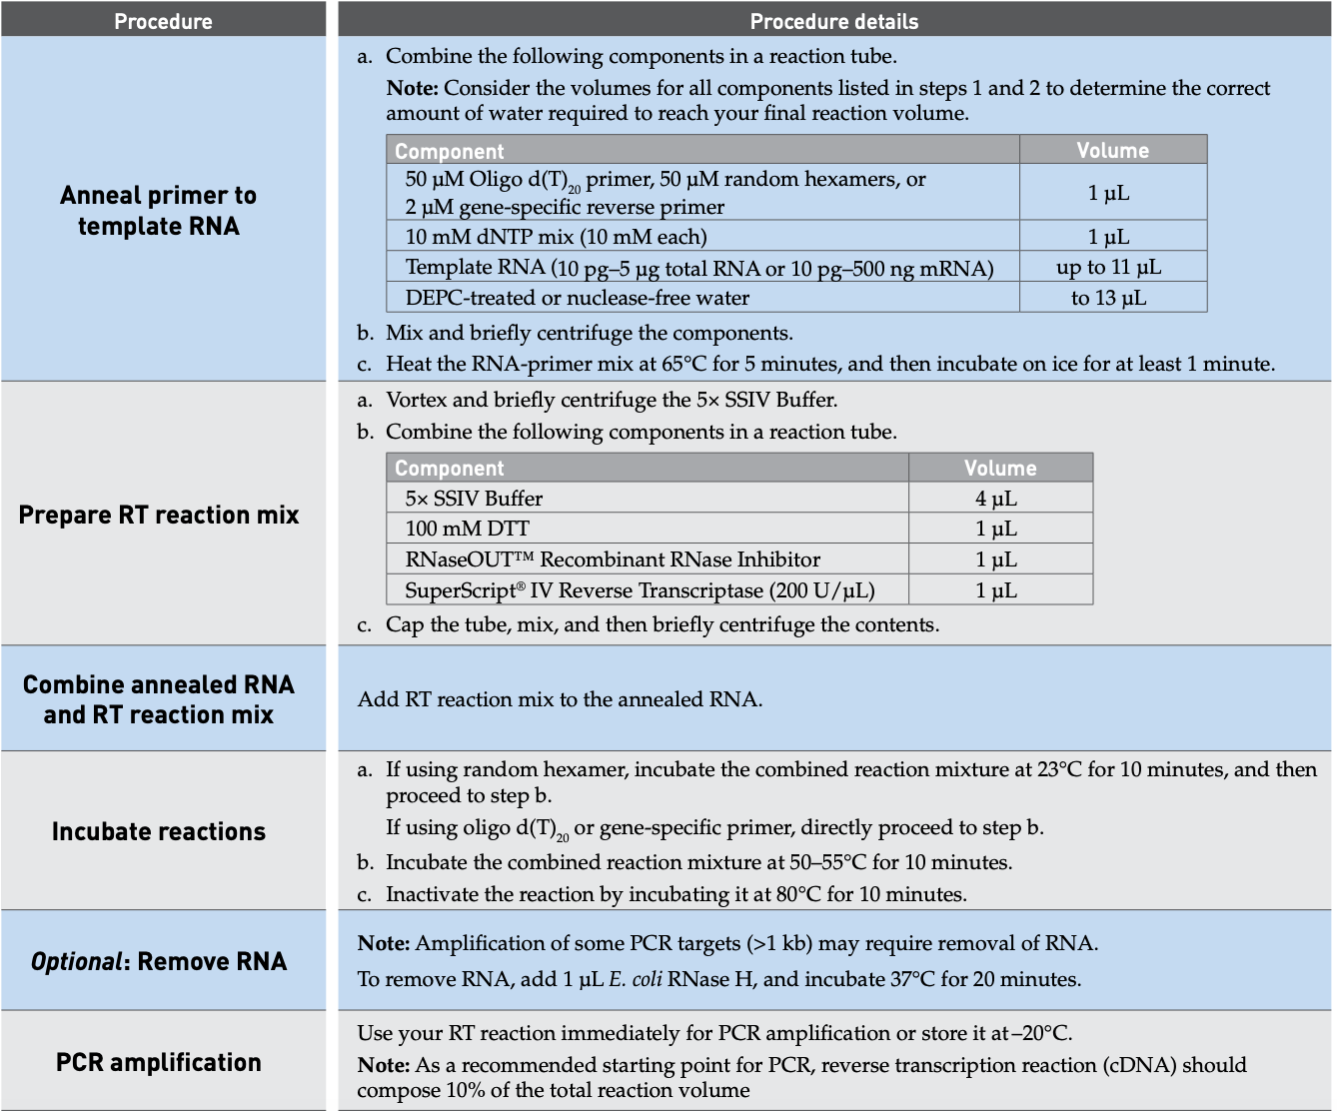

Notes:
- Use 50uM Oligo d(T)20
- Add ~2ug clean RNA template treated with DNase
- Use RNase Inhibitor, Murine (NEB)
- After RNase H treatment, I pooled 2 reactions together and performed a clean-up using DNA Clean & Concentrator (ZYMO RESEARCH). The final elution volume is 30uL.
- It’s better to use fresh synthesized cDNA immediately. If not, store in -20C.

- PCR and electrophoresis

- PCR: Phusion High Fidelity DNA Polymerase was used.
Component 50 ul reaction
Nuclease-free water to 50 ul
5X Phusion HF buffer 10 ul
10 mM dNTPs 1 ul
10 uM Forward Primer 2.5 ul
10 uM Reverse Primer 2.5 ul
Template DNA 3 ul
Phusion DNA Polymerase 0.7 uL

Program
Step 1 98 C 30 s (Matt suggested 3min for this)
Step 2 98 C 10 s
Step 3 60 C 20 s
Step 4 72 C 2 min 30 s
Repeat steps 2-4 for 38 cycles
Step 5 72 C 10 min
Step 6 4 C hold

Notes:
- My transcript is not expressed at a high level. So I added 3 uL of cDNA (~90ng) as template in a 50 uL reaction
- Set annealing temp based on the NEB Tm Calculator for Phusion polymerase specifically
- I usually do four tubes of 50uL reaction because the downstream gel cutting will lose a lot

- Electrophoresis
0.8% agarose
Cut and extract DNA from gel using GeneJET GEL Extraction Kit (thermo scientific)

Notes:
- Use the minimum elution buffer volume because the gel extraction efficiency is low for long fragments.

- Restriction enzyme treatment

- Find customized protocol for double digestion in NEBcloner
http://nebcloner.neb.com/#!/redigest

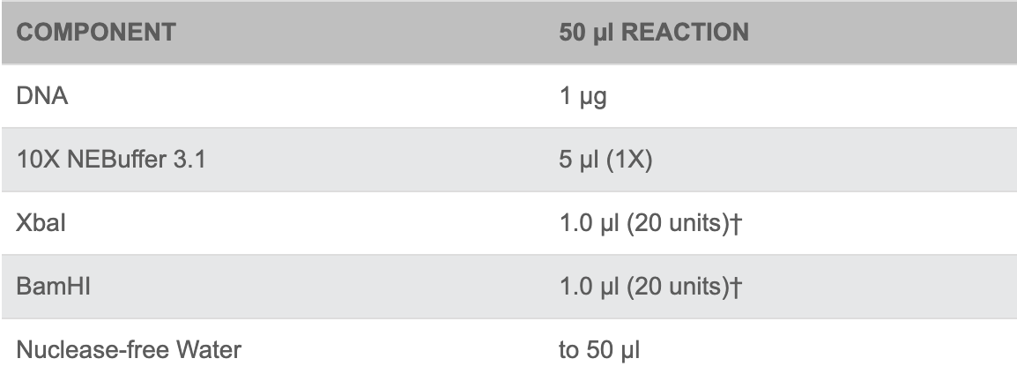
- Incubate at 37 C for 60 min
- Heat inactivate the enzyme by 65 C for 20min
- Clean up the reaction with DNA Clean & Concentrator (ZYMO RESEARCH)

- Ligation

- T4 DNA ligase (NEB)
Component 20 uL Reaction
T4 DNA ligase buffer 2ul
Vector DNA (3kb) 50 ng
Insert DNA (4kb) 200 ng
Nuclease-free water to 20 ul
T4 DNA ligase 1 ul

*based on a molar ratio of 1:3 vector to insert

- Gently mix and ant incubate under room temperature for 1 hour
- Heat inactivate at 65 C for 10min

- Transformation and PCR verification

- Take 5 ul ligation reaction and do heat-shock transformation using NEB Turbo Competent E. coli cells. The protocol
https://www.neb.com/protocols/0001/01/01/high-efficiency-transformation-protocol-c2984

- After the bacteria grow, pick at least 30 colonies on the plate and do colony-PCR using Taq polymerase. The pair of primer used can amplify a short specific region in my transcript of interest.

Note:
- I only identified two out of 30 colonies that have PCR band. So the efficiency of transformation for long fragments are low.

- Design primers every 500 ~ 600 bp for walking through the 4kb transcript by Sanger sequencing.

